Change a site address
Note
This feature is not available for Office 365 Government GCC High customers.
As a global or SharePoint admin in your organization, you can change the URL for the following types of sites (previously called "site collections"):
- Office 365 group-connected team sites
- Modern team sites that don't belong to an Office 365 group
- Communication sites
- Classic team sites
You can change only the address of the site within the URL, for example:
https://contoso.sharepoint.com/sites/projectx
to https://contoso.sharepoint.com/sites/projecty
You can't change the domain ("contoso" in the previous example) or any other part of the path. For example, you can't move the site from "/sites" to "/teams."
It can take about 10 minutes to change the site address (depending on the size of the site), and the site will be read-only during this time. We recommend changing addresses during times when site usage is low.
You can change the address of up to 100 sites at a time. To change an additional site address, wait for another change to finish.

Communicate the address change to users
Before you change the address of a site, it's important to communicate the change to site users (generally anyone with the ability to edit or view the site). This can help reduce user confusion and calls to your help desk. Review the effects of changing a site address and let users know the following information:
- When the change will happen
- What the new URL will be
- Users should close their files and not make edits during the address change
- Users should check the site recycle bin to make sure it contains no files they want to keep
- File permissions and sharing won't change

Change a site address in the new SharePoint admin center
- Go to the Active sites page of the new SharePoint admin center and sign in with an account that has admin permissions for your organization.
Note
If you have Office 365 Germany, sign in to the Microsoft 365 admin center, then browse to the SharePoint admin center and open the Active sites page.
If you have Office 365 operated by 21Vianet (China), sign in to the Microsoft 365 admin center, then browse to the SharePoint admin center and open the Active sites page.
- Click the site name to open the details pane.
- On the General tab, under URL, select Edit.
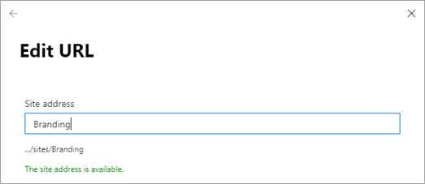
- Enter the new site address, and then select Save.
Note
You can't change the address of hub sites, sites that are locked or on hold, or of sites that have BCS connections.
When you change a site address, we create a redirect at the previous address. If you want to reuse the previous address, you need to delete the redirect. Learn how

